**TRINITY INTERNATIONAL COLLEGE**



**HTML LAB REPORT**

**(COMPUTER SCIENCE­)**

**SUBMITTED BY: SUBMITTED TO:**

**NAME:Nitin Maharjan**

**GRADE: XI “DK” (AST)**

**REGISTRATION NUMBER:**

A Project On

**WEB PAGE DESIGINING**

Submitted as a partial fulfillment of requirement of the curriculum of

GRADE-XI (Computer Science) under HSEB

Submitted By:

**Nitin Maharjan**

Under Supervision Of

**AST sir**

Date:

**2/5/2020**



**TRINITY INTERNATIONAL COLLEGE**

**Dillibazar Height, Kathmandu**

**Nepal**

ACKNOWLEDGEMENT

I take this opportunity to express my profound gratitude and deep regards to my guide Mr. AST for his exemplary guidance, monitoring and constant encouragement throughout the course of this project. The blessing, help and guidance, given by him time to time shall carry me a long way in this journey of life on which I am about to embark also take this opportunity to express a deep sense of gratitude to Mr. AST for his cordial support, valuable information and guidance which helped me in completing this task through various stages.

I am obliged to staff members of trinity international college, for the valuable information provided by them in their respective fields, I am grateful for their cooperation during the period of my assignment. I would to like thank all those who directly or indirectly played a vital role from their own positions to successfully accomplish this project.

Lastly, I thank almighty, my parents, brothers, sisters, and friends for their constant encouragement without which the assignment would not be possible.

**TRINITY INTERNATIONAL COLLEGE**

**Dillibazar Height, Kathmandu**



Certificate

This is to certify that Mr. Ankit Singh has successfully completed his project work as per the requirement of the curriculum of GRADE-XI (Computer Science) under HSEB. S/he has completed his project work within the prescribed period.

**Registration No. :-**

**Symbol number :-**

(Internal Examiner)

(External Examiner)

**OBJECTIVES**

This project comes with the basic objective of helping us students to excel in various included topics of computer science. HTML is the specific chapter we are expected to work successfully on. The main objectives of the project are enumerated below:-

* Excel in web designing using Hyper Text Markup Language.
* To establish a deep knowledge in web designing.
* To successfully adapt the techniques of web designing.
* Develop a webpage individually and design it.
* Learn the function of various tags.
* Learn CSS and apply its importance in webpage designing.

After the completion of the project, we will most certainly acquire adequate knowledge on the enlisted topics which will behold strong significance to our education and to our future

Table of contents

S.N. TOPIC PAGE NO

1. Acknowledgement 1
2. Objectives 2
3. Table of Contents 3
4. Background Theory 4

4.1 Web Designing and HTML 4 - 7

1. Work Done 8
   1. Source Code and Screenshots 8
      1. HTML Codes and Screenshots 8 - 24
      2. CSS Code 25
2. Conclusion and future work 26
3. Bibliography 27

Theory on HTML



HTML (Hypertext Markup Language) is the most basic building block of the Web. It defines the meaning and structure of web content. Other technologies besides HTML are generally used to describe a web page's appearance/presentation ([CSS](https://developer.mozilla.org/en-US/docs/Web/CSS)) or functionality/behavior ([JavaScript](https://developer.mozilla.org/en-US/docs/Web/JavaScript)).

"Hypertext" refers to links that connect web pages to one another, either within a single website or between websites. Links are a fundamental aspect of the Web. By uploading content to the Internet and linking it to pages created by other people, you become an active participant in the World Wide Web.

HTML uses "markup" to annotate text, images, and other content for display in a Web browser. HTML markup includes special "elements" such :

[<head>](https://developer.mozilla.org/en-US/docs/Web/HTML/Element/head), [<title>](https://developer.mozilla.org/en-US/docs/Web/HTML/Element/title), [<body>](https://developer.mozilla.org/en-US/docs/Web/HTML/Element/body), [<header>](https://developer.mozilla.org/en-US/docs/Web/HTML/Element/header), [<footer>](https://developer.mozilla.org/en-US/docs/Web/HTML/Element/footer), [<article>](https://developer.mozilla.org/en-US/docs/Web/HTML/Element/article), [<section>](https://developer.mozilla.org/en-US/docs/Web/HTML/Element/section), [<p>](https://developer.mozilla.org/en-US/docs/Web/HTML/Element/p), [<div>](https://developer.mozilla.org/en-US/docs/Web/HTML/Element/div), [<span>](https://developer.mozilla.org/en-US/docs/Web/HTML/Element/span), [<img>](https://developer.mozilla.org/en-US/docs/Web/HTML/Element/img), [<aside>](https://developer.mozilla.org/en-US/docs/Web/HTML/Element/aside), [<audio>](https://developer.mozilla.org/en-US/docs/Web/HTML/Element/audio), [<canvas>](https://developer.mozilla.org/en-US/docs/Web/HTML/Element/canvas), [<datalist>](https://developer.mozilla.org/en-US/docs/Web/HTML/Element/datalist), [<details>](https://developer.mozilla.org/en-US/docs/Web/HTML/Element/details), [<embed>](https://developer.mozilla.org/en-US/docs/Web/HTML/Element/embed), [<nav>](https://developer.mozilla.org/en-US/docs/Web/HTML/Element/nav), [<output>](https://developer.mozilla.org/en-US/docs/Web/HTML/Element/output), [<progress>](https://developer.mozilla.org/en-US/docs/Web/HTML/Element/progress), [<video>](https://developer.mozilla.org/en-US/docs/Web/HTML/Element/video), [<ul>](https://developer.mozilla.org/en-US/docs/Web/HTML/Element/ul), [<ol>](https://developer.mozilla.org/en-US/docs/Web/HTML/Element/ol), [<li>](https://developer.mozilla.org/en-US/docs/Web/HTML/Element/li) and many others.

An HTML element is set off from other text in a document by "tags", which consist of the element name surrounded by "<" and ">".  The name of an element inside a tag is case insensitive. That is, it can be written in uppercase, lowercase, or a mixture. For example, the <title> tag can be written as <Title>, <TITLE>,.

HTML can embed programs written in a [scripting language](https://en.wikipedia.org/wiki/Scripting_language) such as [JavaScript](https://en.wikipedia.org/wiki/JavaScript), which affects the behavior and content of web pages. Inclusion of CSS defines the look and layout of content. The [World Wide Web Consortium](https://en.wikipedia.org/wiki/World_Wide_Web_Consortium) (W3C), former maintainer of the HTML and current maintainer of the CSS standards, has encouraged the use of CSS over explicit presentational HTML since 1997.

HTML TAGS  
  
The following are 10 HTML Tags you will use often. As you advance in HTML you will get to know more tags that are also useful.  
  
1. HTML Headings  
  
Description: Defines HTML headings  
  
HTML headings are defined with the <h1> to <h6> tags:  
  
Example  
  
<h1>This is a h1 heading</h1>  
<h2>This is a h2 heading</h2>  
<h3>This is a h3 heading</h3>

2. HTML Paragraphs  
  
Description: Defines a paragraph  
  
HTML paragraphs are defined with the <p> tag:  
  
Example  
<p>This is the first paragraph.</p>  
<p>This is another paragraph.</p>  
  
3. HTML Links  
  
Description: Defines a hyperlink  
  
HTML links are defined with the <a> tag:  
  
Example  
  
<a href="https://www.classgist.com">classgist</a>  
  
The link's destination is specified in the href attribute.  
  
Attributes are used to provide additional information about HTML elements.  
  
4. HTML Images  
  
Description: Defines an image  
  
HTML images are defined with the <img> tag.  
  
The source file (src), alternative text (alt), and size (width and height) are provided as attributes:  
  
Example  
  
<img src="logo.jpg" alt="sitelogo" width="100" height="100">

5. HTML Tables  
  
Description: Defines a table

Tables are used to arrange data like text, images, links, other tables, etc. into rows and columns of cells

HTML tables are defined with the <table> tag:  
  
Example  
  
<table border="1" cellpadding="5" cellspacing="5">  
<tr>  
<td>One</td>  
<td>Two</td>  
</tr>  
<tr>  
<td>Three</td>  
<td>Four</td>  
</tr>  
</table>  
  
The border, cellpadding and cellspacing are attributes. Attributes are used to provide additional information about HTML elements.

Features of HTML:

HTML is the most common used language to write web pages. It has recently gained popularity due to its advantages such as: -

* It is the language which can be easily understood and can be modified.
* Effective presentations can be made with the HTML with the help of its all formatting tags.
* It provides the more flexible way to deign web pages along with the text.
* Links can also be added to the web pages so it helps the readers to browse the information of their interest.
* You can display HTML documents on any platforms such as Macintosh, Windows and Linux etc.
* Graphics, videos and sounds can also be added to the web pages which give an extra attractive look to your web pages.

HTML Versions

Since the time HTML was invented there are lots of HTML versions in market, the brief introduction about the HTML version is given below:

HTML 1.0: The first version of HTML was 1.0, which was the barebones version of HTML language, and it was released in1991.

HTML 2.0: This was the next version which was released in 1995, and it was standard language version for website design. HTML 2.0 was able to support extra features such as form-based file upload, form elements such as text box, option button, etc.

HTML 3.2: HTML 3.2 version was published by W3C in early 1997. This version was capable of creating tables and providing support for extra options for form elements. It can also support a web page with complex mathematical equations. It became an official standard for any browser till January 1997. Today it is practically supported by most of the browsers.

HTML 4.01: HTML 4.01 version was released on December 1999, and it is a very stable version of HTML language. This version is the current official standard, and it provides added support for style sheets (CSS) and scripting ability for various multimedia elements.

HTML5: HTML5 is the newest version of Hypertext Markup language. The first draft of this version was announced in January 2008. There are two major organizations one is W3C (World Wide Web Consortium), and another one is WHATWG( Web Hypertext Application Technology Working Group) which are involved in the development of HTML 5 version, and still, it is under development.

**Source code**

1. **First Page**

<html>

<head>

<script src="https://kit.fontawesome.com/6eeea46a68.js" crossorigin="anonymous">

</script>

<title>CLICK!-find your Moment</title>

<link rel="stylesheet" href="1.css">

<link rel="shortcut icon" type="image/x-icon" href="icon.jpg">

</head>

<body>

<div class="logo">

<i class="fas fa-camera-retro"></i>

<div class="text">click!</div>

</div>

<div class="base"><i class="far fa-lightbulb"></i></div>

<div class="mid">

start yoUr journey

</div>

<div class="contact">

<div class="box">

<a class="button" href="#popup1"><i class="fas fa-mobile-alt"></i>

<i class="fas fa-envelope"></i> CONTACT <i class="fas fa-paper-plane"></i>

<i class="fas fa-at"></i></a>

</div>

<div id="popup1" class="overlay">

<div class="popupforcontact">

<h2><i class="fas fa-phone-volume"></i>call</h2>

<a class="close" href="#">&times;</a>

<div class="content">

</div></div></div></div></div>

<a href="index.html" class="btnmain">Let's start</a>

<button class="open-button" onclick="openForm()">Chat with Us</button>

<div class="chat-popup" id="myForm">

<form action="/action_page.php" class="form-container">

<div class="online"><h1>Online</h1></div>

<label for="msg"><b>Message</b></label>

<textarea placeholder="Type message.." name="msg" required></textarea>

<button type="submit" class="btn">Send</button>

<button type="button" class="btn cancel" onclick="closeForm()">Close</button>

</form>

</div>

<script>

function openForm() {

document.getElementById("myForm").style.display = "block";

}

function closeForm() {

document.getElementById("myForm").style.display = "none";

}

</script>

</body>

</html>

**Screenshots of First Page**

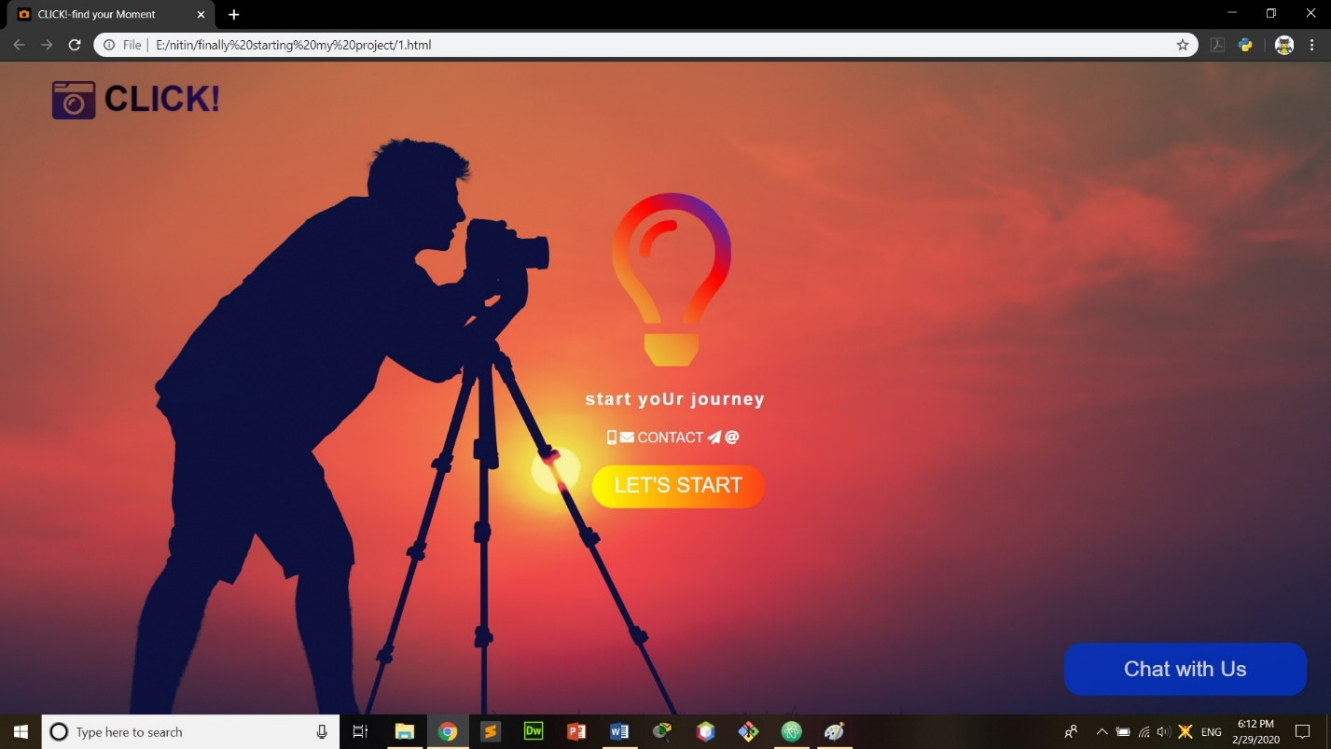

1. **Home Page**

<head>

<title>CLICK!-find your Moment</title>

<link rel="stylesheet" href="layout.css" type="text/css" />

<link rel="shortcut icon" type="image/x-icon" href="icon.jpg">

<script src="https://kit.fontawesome.com/6eeea46a68.js" crossorigin="anonymous">

</script>

</head>

<body id="top">

<div class="wrapper col2">

<div id="header">

<div id="logo">

<i class="fas fa-camera-retro"></i>

<h1><a href="index.html">Click!</a></h1>

</div>

<ul id="topnav">

<li class="last"><a href="project/login1.html">Login</a></li>

<li><a href="Our Services/ourservice.html">Our Services</a></li>

<li><a href="2.html">Gallery</a></li>

<li class="active"><a href="index.html">Home</a></li>

</ul>

<br class="clear" />

</div></div>

<div class="wrapper col3">

<div id="gallery">

<ul>

<li class="placeholder" style="background-image:url('main.jpg');">Image Holder</li>

<li><a class="swap" href="#"><img src="images/fulls/01.jpg" alt="" /><span>

<img src="images/fulls/01.jpg" width="950" height="370" alt="" /></span></a></li>

<li><a class="swap" href="#"><img src="images/fulls/03.jpg" alt="" /><span>

<img src="images/fulls/03.jpg" width="950" height="370" alt="" /></span></a></li>

<li><a class="swap" href="#"><img src="images/fulls/06.jpg" alt="" /><span>

<img src="images/fulls/06.jpg" width="950" height="370" alt="" /></span></a></li>

<li><a class="swap" href="#"><img src="images/fulls/07.jpg" alt="" /><span>

<img src="images/fulls/07.jpg" width="950" height="370" alt="" /></span></a></li>

<li class="last"><a class="swap" href="#"><img src="images/fulls/09.jpg" alt="" /><span>

<img src="images/fulls/09.jpg" width="950" height="370" alt="" /></span></a></li>

</ul></div></div>

<div class="wrapper col4">

<div id="services">

<ul>

<li><a href="#"><strong>Weddings</strong><img src="photo/1.jpg" alt="" /></a></li>

<li><a href="#"><strong>Corporate</strong><img src="photo/2.jpg" alt="" /></a></li>

<li><a href="#"><strong>Lifestyle</strong><img src="photo/3.jpg" alt="" /></a></li>

<li class="last"><a href="#"><strong>Events</strong><img src="photo/4.jpg" alt="" /></a></li>

<li><a href="#"><strong>Artistic</strong><img src="photo/5.jpg" alt="" /></a></li>

<li><a href="#"><strong>Infants</strong><img src="photo/6.jpg" alt="" /></a></li>

<li><a href="#"><strong>Architecture</strong><img src="photo/7.jpg" alt="" /></a></li>

<li class="last"><a href="#"><strong>Black &amp; White</strong><img src="photo/8.jpg" alt="" /></a></li>

</ul>

<br class="clear" />

</div></div>

<div class="wrapper col5">

<div id="container">

<div id="content">

<h2>About click!</h2>

<p>Click was created not only for us but for you to capture your precious moments.</p>

</div>

<div id="column">

</div>

<br class="clear" />

</div></div>

<div class="wrapper col6">

<div id="footer">

<div id="contactform">

<h2>Why Not Contact Us Today !</h2>

<form action="#" method="post">

<fieldset>

<legend>Contact Form</legend>

<label for="fullname">Name:

<input id="fullname" name="fullname" type="text" value="" />

</label>

<label for="emailaddress" class="margin">Email:

<input id="emailaddress" name="emailaddress" type="text" value="" />

</label>

<label for="message">Message:<br />

<textarea id="message" name="message" cols="40" rows="4"></textarea>

</label><p>

<input id="submitform" name="submitform" type="submit" value="Submit" />

&nbsp;

<input id="resetform" name="resetform" type="reset" value="Reset" />

</p></fieldset>

</body>

</html>

**Screenshots of home page**

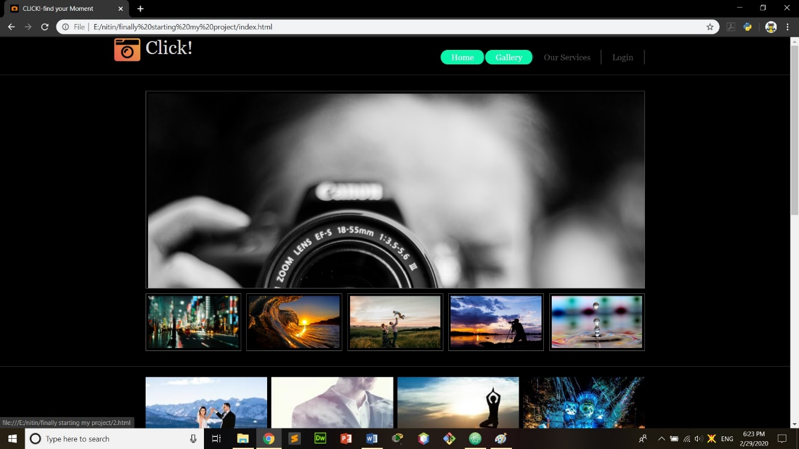

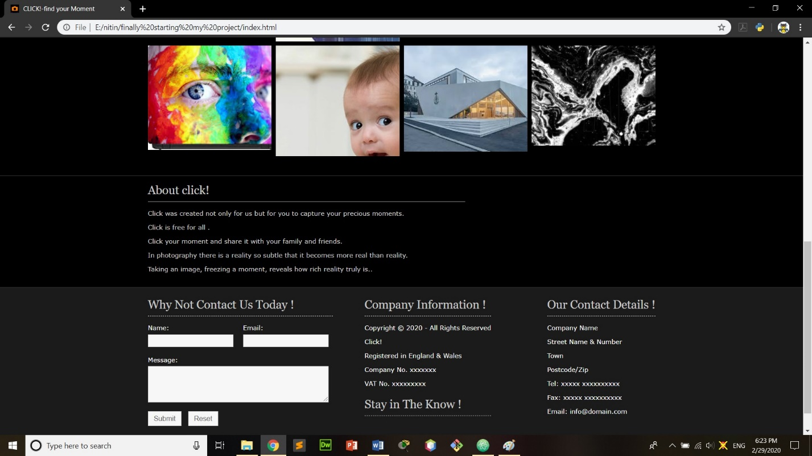

1. **Gallery Page**

<html>

<head>

<title>CLICK!-find your Moment</title>

<link rel="shortcut icon" type="image/x-icon" href="icon.jpg">

<link rel="stylesheet" href="assets/css/main.css" />

<noscript><link rel="stylesheet" href="assets/css/noscript.css" /></noscript>

</head>

<body class="is-preload-0 is-preload-1 is-preload-2">

<div id="main">

<header id="header">

<h1>click!</h1>

<p>Follow your passion</p>

<ul class="icons">

<li><a href="#" class="icon brands fa-twitter"><span class="label">Twitter</span></a></li>

<li><a href="#" class="icon brands fa-instagram"><span class="label">Instagram</span></a></li>

<li><a href="#" class="icon brands fa-github"><span class="label">Github</span></a></li>

<li><a href="#" class="icon fa-envelope"><span class="label">Email</span></a></li>

</ul>

</header>

<section id="thumbnails">

<article>

<a class="thumbnail" href="images/fulls/01.jpg" data-position="left center"><img src="images/thumbs/01.jpg" alt="" /></a>

<h2>night city</h2>

<p>lonely nights with camera.</p>

</article>

<article>

<a class="thumbnail" href="images/fulls/02.jpg"><img src="images/thumbs/02.jpg" alt="" /></a>

<h2>sea your dream</h2>

<p>travel to be a pirate.</p>

</article>

<article>

<a class="thumbnail" href="images/fulls/03.jpg" data-position="top center"><img src="images/thumbs/03.jpg" alt="" /></a>

<h2>waves</h2>

<p>surf till you die.</p>

</article><article>

<a class="thumbnail" href="images/fulls/04.jpg"><img src="images/thumbs/04.jpg" alt="" /></a>

<h2>lonely tracks</h2>

<p>walk alone .</p>

</article>

<article>

<a class="thumbnail" href="images/fulls/05.jpg" data-position="top center"><img src="images/thumbs/05.jpg" alt="" /></a>

<h2>snow fall</h2>

<p>fall of dreams.</p>

</article>

<article>

<a class="thumbnail" href="images/fulls/06.jpg"><img src="images/thumbs/06.jpg" alt="" /></a>

<h2>rise</h2>

<p>plz dont catch.</p>

</article>

<article>

<a class="thumbnail" href="images/fulls/07.jpg"><img src="images/thumbs/07.jpg" alt="" /></a>

<h2>passion</h2>

<p>dont care about being hunted.</p>

</article>

<article>

<a class="thumbnail" href="images/fulls/08.jpg"><img src="images/thumbs/08.jpg" alt="" /></a>

<h2>flowers</h2>

<p>dont let them rot .</p>

</article>

<article>

<a class="thumbnail" href="images/fulls/09.jpg"><img src="images/thumbs/09.jpg" alt="" /></a>

<h2>drop and dropping</h2>

<p>nothing to say just drop.</p>

</article>

<article>

<a class="thumbnail" href="images/fulls/10.jpg"><img src="images/thumbs/10.jpg" alt="" /></a>

<h2>fallen leaf</h2>

<p>just let me fall.</p>

</article>

<article>

<a class="thumbnail" href="images/fulls/11.jpg"><img src="images/thumbs/11.jpg" alt="" /></a>

<h2>sweet nectar</h2>

<p>have a drink.</p>

</article>

<article>

<a class="thumbnail" href="images/fulls/12.jpg"><img src="images/thumbs/12.jpg" alt="" /></a>

<h2>time</h2>

<p>you dont have much left.</p>

</article>

</section>

</div>

<script src="assets/js/jquery.min.js"></script>

<script src="assets/js/browser.min.js"></script>

<script src="assets/js/breakpoints.min.js"></script>

<script src="assets/js/main.js"></script>

</body>

</html>

**Screenshots of Gallery Page**

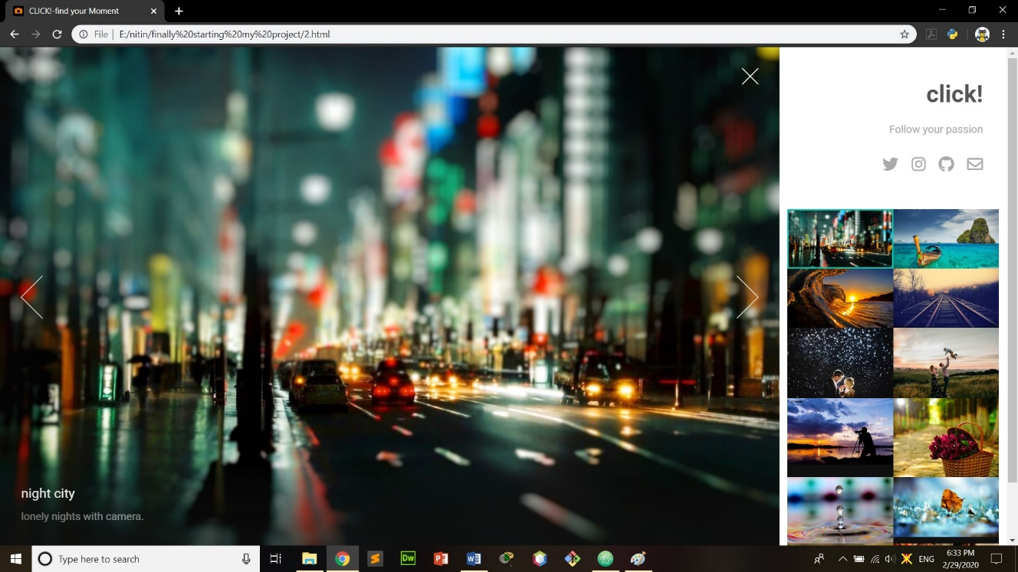

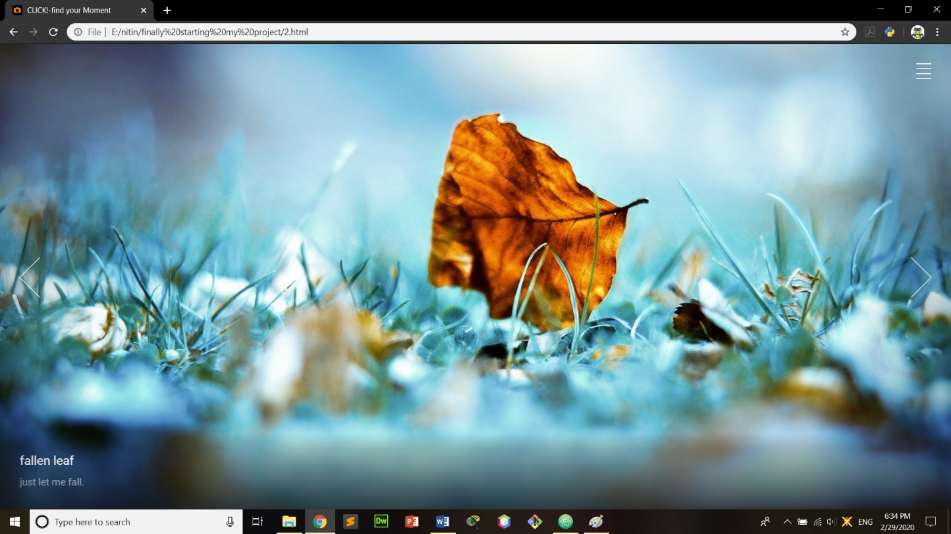

1. **Our Services Page**

<html >

<head>

<title>CLICK!-find your Moment</title>

<link rel="shortcut icon" type="image/x-icon" href="icon.jpg">

<link rel="stylesheet" href="style.css">

<link rel="stylesheet" href="https://use.fontawesome.com/releases/v5.3.1/css/all.css">

<meta name="viewport" content="width=device-width, initial-scale=1.0">

</head><body>

<div class="services">

<h1>Our Services</h1>

<div class="cen">

<div class="service">

<i class="fas fa-camera-retro"></i>

<h2>beautiful picture</h2>

<p>Photography is a way of feeling, of touching, of loving. What you have caught on film is captured forever…</p>

</div><div class="service">

<i class="fas fa-truck"></i>

<h2>everywhere</h2>

<p>We are making photographs to understand what our lives mean to us.</p>

</div><div class="service">

<i class="fab fa-angellist"></i>

<h2>best</h2>

<p>The best thing about a picture is that it never changes, even when the people in it do.</p>

</div>

<div class="service">

<i class="fas fa-apple-alt"></i>

<h2>fast</h2>

<p>We are fast.Faster and cheaper than apple.</p>

</div><div class="service">

<i class="fas fa-archway"></i>

<h2>creative</h2>

<p>A tear contains an ocean. A photographer is aware of the tiny moments in a persons life that reveal greater truths..</p>

</div><div class="service">

<i class="far fa-smile-wink"></i>

<h2>review</h2>

<p>we review all your comments and try to make ourselves better.</p>

</div></div></div>

</body>

</html>

**Screenshots of Our Services Page**

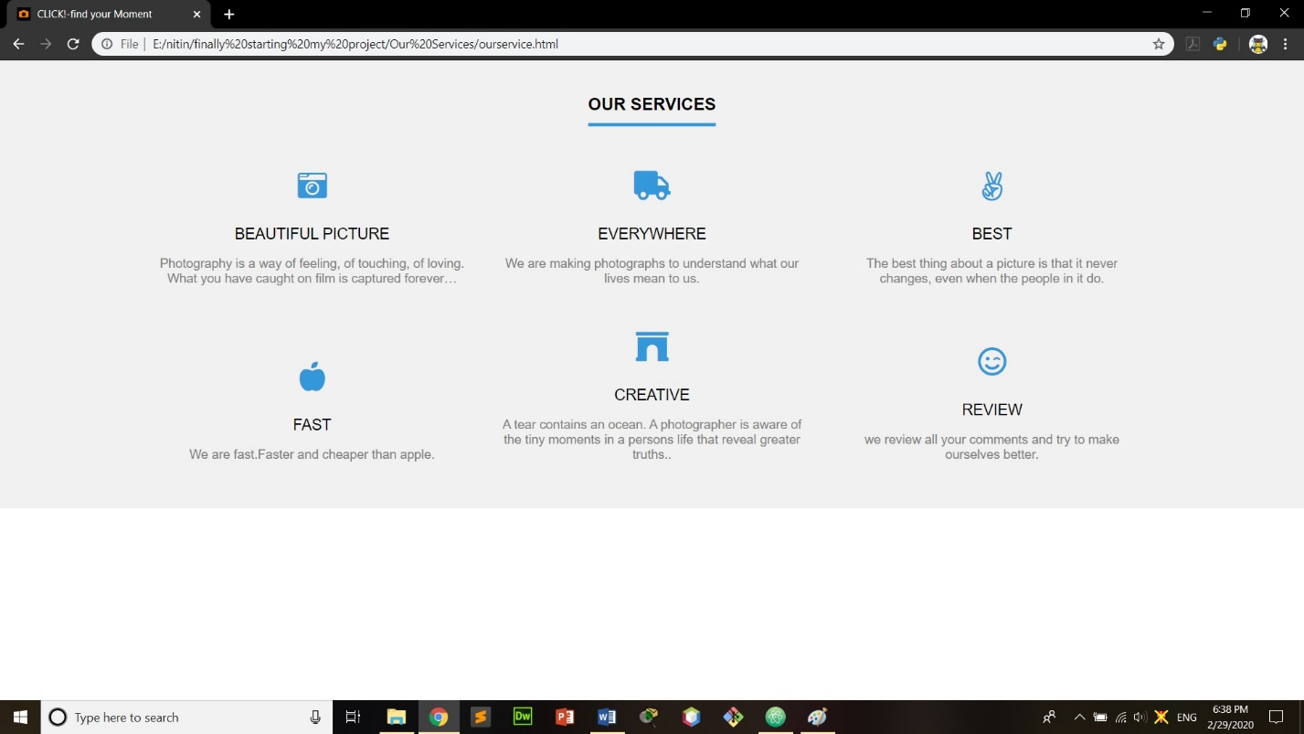

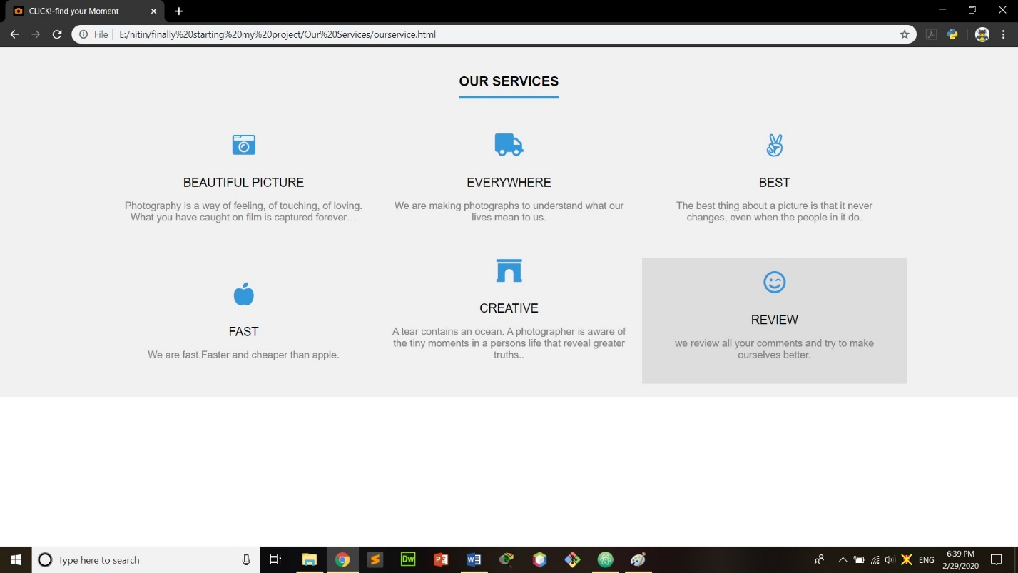

1. **Fourth Generation Page**

<html>

<head>

<link rel="stylesheet" href="style.css">

</head>

<body>

<div class="login">

<img src="4.png" class="avatar">

<h2 class="h2">Login here </h2>

<p>User name</p>

<form>

<input type="text" name="" placeholder="Your Username">

<p>Password</p>

<input type="password" name="" placeholder="Your Password">

<p></p>

<input type="submit" name="" placeholder="submit">

</form>

</div>

</body>

</html>

**Screenshot of Fourth Generation Page**

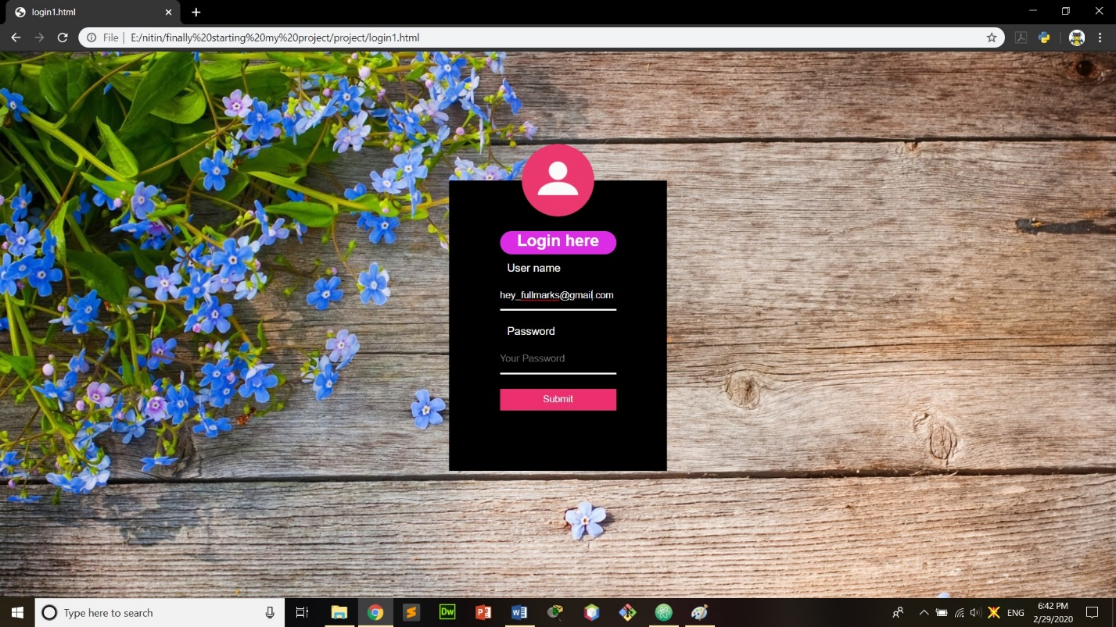

1. **Sign Up Page**

<head>

<title>CLICK!-find your Moment</title>

<link rel="stylesheet" href="login.css" type="text/css" />

<link rel="shortcut icon" type="image/x-icon" href="icon.jpg">

<script src="https://kit.fontawesome.com/6eeea46a68.js" crossorigin="anonymous">

</script>

</head>

<body >

<div class="box">

<div class="form">

<form class ="input ">

<div class="avatar">

<img src="avatar.png" height =100px width=100px>

</div>

<h1 class ="header">

<p></p><p></p><p>

sign up box</p>

</h1><p>username</p>

<input type ="text" name ="" placeholder ="your username">

<p>password</p>

<input type ="password" name ="" placeholder ="your password">

<p><input type ="submit" name="" placeholder="submit">

</p></form>

</div>

</form>

</div>

</body>

</html>

**Screenshots of Sign up Page**

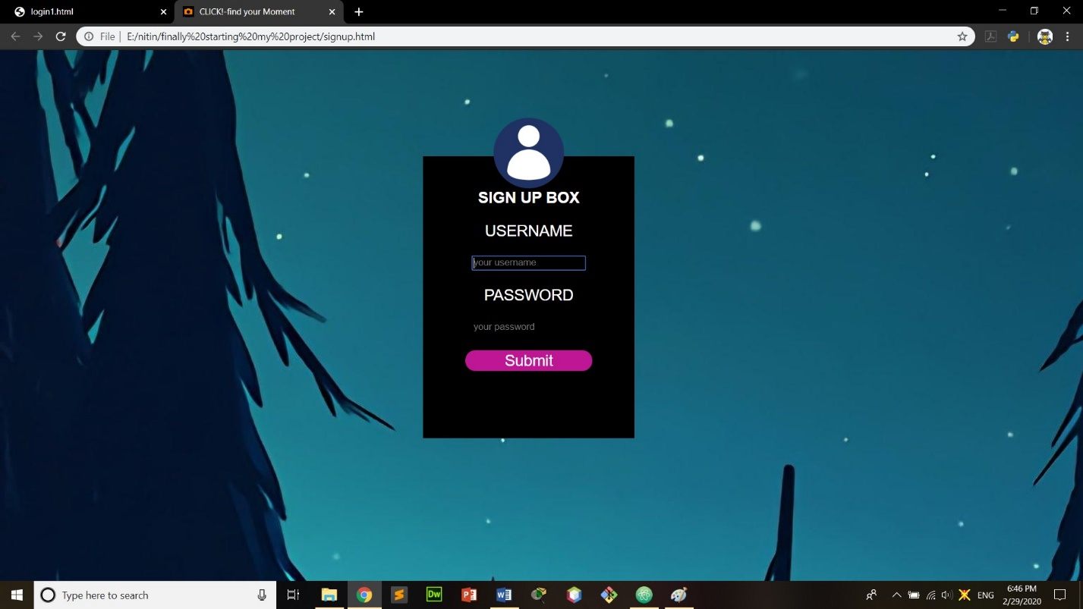

**CSS Code**

**1)first page**

body{

margin: 0;

padding: 0;

background-image: url("2.jpeg");

background-size: cover;

}

.fa-camera-retro{

text-align: center;

font-size: 50px;

width:150px;

margin-top: 20px;

margin-left: 10px;

background: -webkit-linear-gradient(45deg,#10126E ,#4E1707);

-webkit-background-clip:text;

-webkit-text-fill-color:transparent;

}

.text{

position: absolute;

top: 20px;

left:120px;

font-size: 40px;

font-family: sans-serif;

text-transform: uppercase;

background-image:linear-gradient(90deg,#060013, #2E0F70,#4D1FAD);

-webkit-text-fill-color:transparent;

-webkit-background-clip:text;

font-weight: bold;

text-shadow: 0 0 2px rgba(0,0,0,.5);

}

.fa-lightbulb{

position: absolute;

top: 20%;

left:46%;

font-size: 200px;

text-align: center;

background: -webkit-linear-gradient(45deg,#EAEF34 ,#EF8934,#FF0000,#0039FF );

-webkit-background-clip:text;

-webkit-text-fill-color:transparent;

}

.mid{

position: absolute;

top: 50%;

left:44%;

text-align: center;

font-size: 20px;

font-family: sans-serif;

font-weight: bold;

color: #fff;

letter-spacing: 2px;

padding: 0;

}

.button {

position: absolute;

top: 55%;

left:45%;

text-align: center;

font-family: sans-serif;

font-size: 1em;

padding: 10px;

color: #fff;

border: 0px solid #06D85F;

border-radius: 20px/50px;

text-decoration: none;

cursor: pointer;

transition: all 0.3s ease-out;

}

.overlay {

position: fixed;

top: 0;

bottom: 0;

left: 0;

right: 0;

background: rgba(0, 0, 0, 0.7);

transition: opacity 500ms;

visibility: hidden;

opacity: 0;

}

.overlay:target {

visibility: visible;

opacity: 1;

}

.popupforcontact {

margin: 70px auto;

padding: 20px;

background: #fff;

border-radius: 5px;

width: 30%;

position: relative;

transition: all 5s ease-in-out;

}

.popupforcontact h2 {

margin-top: 0;

color: #333;

font-family: Tahoma, Arial, sans-serif;

}

.popupforcontact .close {

position: absolute;

top: 20px;

right: 30px;

transition: all 200ms;

font-size: 30px;

font-weight: bold;

text-decoration: none;

color: #333;

}

.popupforcontact .close:hover {

color: #06D85F;

}

.popupforcontact .content {

max-height: 30%;

overflow: auto;

}

@media screen and (max-width: 700px){

.box{

width: 70%;

}

.popupforcontact{

width: 70%;

}

}

2) Home page

html

{

overflow-y:scroll;

}

body

{

margin:0;

padding:0;

font-size:12px;

font-family:verdana, Arial, Helvetica, sans-serif;

color:#CCCCCC;

background-color:#2E2E2E;

}

.justify{text-align:justify;}

.bold{font-weight:bold;}

.center{text-align:center;}

.right{text-align:right;}

.nostart{margin:0; padding:0; list-style-type:none;}

.clear{clear:both;}

br.clear{clear:both; margin-top:-15px;}

.fa-camera-retro{

text-align: center;

font-size: 50px;

width:150px;

background: -webkit-linear-gradient(45deg,#eb345c,#ebcf34);

-webkit-background-clip:text;

-webkit-text-fill-color:transparent;

position: absolute;

left: -110px;

}

a

{

outline:none;

text-decoration:none;

}

.fl_left, .imgl{float:left;}

.fl_right, .imgr{float:right;}

img

{margin:0;

padding:0;

border:0;

}

.imgl, .imgr

{

border:1px solid #666666;

padding:5px;

}

.imgl

{margin:0 8px 8px 0;

clear:left;

}

.imgr

{

margin:0 0 8px 8px;

clear:right;

}

div.wrapper

{

display:block;

width:100%;

margin:0;

text-align:left;

}

div.wrapper h1, div.wrapper h2, div.wrapper h3, div.wrapper h4, div.wrapper h5, div.wrapper h6{margin:0 0 20px 0; padding:0 0 8px 0; font-size:22px; font-weight:normal; font-family:Georgia, "Times New Roman", Times, serif; border-bottom:1px dashed #DDDDDD;}

.col1{color:#333333; background-color:#000000;}

.col2{color:#DBDBDB; background-color:#000000; border-bottom:1px solid #3B3B3B;}

.col3{color:#DBDBDB; background-color:#000000; border-bottom:1px solid #3B3B3B;}

.col4{color:#DBDBDB; background-color:#000000; border-bottom:1px solid #3B3B3B;}

.col5{color:#CCCCCC; background-color:#000000; border-bottom:1px solid #3B3B3B;}

.col5 a{color:#99CC00; background-color:#000000;}

.col6{color:#FFFFFF; background-color:#1B1B1B; border-bottom:1px solid #3B3B3B;}

.col7, .col7 a{color:#CCCCCC; background-color:#2E2E2E;}

**3)** Login page

body{

background-image: url(3.jpg);

margin: 0;

padding: 0;

font-size: 10px;

font-family: sans-serif;

}

.link{

font-family: monospace ;

text-decoration: none;

color: #fff;

font-weight: lighter;

}

.hover{

text-align: left;

margin-top: 0px;

}

.login{

height: 400px;

width:300px;

background: black;

color: #fff;

top: 50%;

left: 50%;

position: absolute;

transform: translate(-50%,-50%);

box-sizing: border-box;

padding: 70px ;

}

.avatar{

height: 100px;

width: 100px;

border-radius: 50%;

position: absolute;

top: -50px;

left: 100px;

}

h2{

margin: 0;

padding: 0 0 20px;

text-align: center;

font-size: 22px;

cursor: pointer;

animation: text;

transition: 0.8s;

}

.h2:hover{

color: #fff;

background-color: #dc2ce6;

height: 30px;

padding: 1px;

margin-bottom: 1px;

border-radius: 50px;

}

p{

font-size: 15px;

margin: 10;

}

.login input{

width: 100%;

margin-bottom: 10px;

}

.login input[type="text"],[type="password"]{

border: none;

background:transparent ;

border-bottom: solid #fff;

outline: none;

color: #fff;

height :40px;

}

.login input[type="submit"]{

border: none;

background: #ed2f6f;

color: #fff;

height: 30px;

cursor: pointer;

transition: 0.8s;

}

.login input[type="submit"]:hover{

color: #fff;

background-color: #dc2ce6;

}

.p{

font-size: 100px;

}

@keyframes h2 {

0%{

margin-top: 50px;

}

30%{

margin-bottom: 10px;

}

}

**Bibliography**

A bibliography is a list of books, articles, government documents, manuscripts and other publications on a subject, described and arranged in some systematic order. Bibliographies may be book-length, and are also found as lists of publications bibliography is a list of all of the sources you have used (whether referenced or not) in the process of researching your work. In general, a bibliography for this project is:

* https://www.google.com/(Google)
* Computer Science, Grade XI
* www.w3schools.com
* http://practisingprograms.blogspot.com/2017/02/class-11-project-details.html

(Practicing Programs)

* Wikipedia [en.wikipedia.org]
* https://www.google.com/images (Google)

This site is used to find various images that were linked with HTML images.